|  |  |
| --- | --- |
| S:\AdminShared\All Staff\Logos\EGC Upward & Onward Logo.jpg | Student Name _______________________    **Eastern Goldfields College**  Mathematics Applications U3&4 2018  Investigation 4 – Finance  1 |

**Task weighting:** 5% **Total Marks:** 30 marks

**Equipment Required** – Computer, calculator, NO Notes **Time:** 110 min

Oliver is 35 years old and has just inherited $300,000 from his father.



Rather than spend it all immediately, he decides to look into some investment options available to him.

He has found the following investment schemes and he is seeking your advice on which one is the better option when considering:

* The term of each scheme   
  i.e. how long the money would last, and
* The return of each scheme over its term i.e. how much each scheme earns

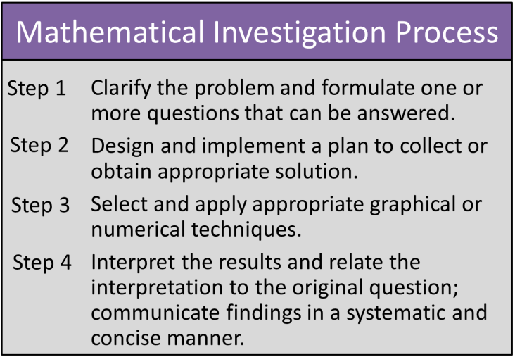You are required to follow the investigation process to determine which would be the better option for Oliver.

5 marks

5 marks

15 marks

5 marks

